**BadgerFilm v.1.2 Manual**

**QuickStart Guide**

BadgerFilm is a thin film analysis program that calculates the thickness and composition of films on substrate. The program is developed in Visual Basic and requires a Windows OS (or emulator) and the .NET Framework 4.5.2 or higher version.

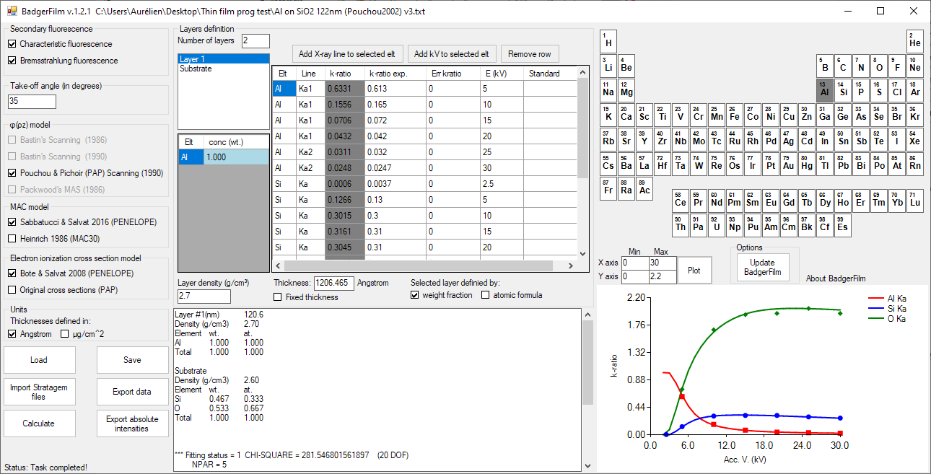

**5**

**7**

**8**

**9**

**0**

**6**

**10**

**1**

**2**

**4**

**3**

**11**

**0.** Select the secondary fluorescence to calculate.  
Set the take off angle of the spectrometers.  
Select the ϕ(ρz) model to use (only PAP for now).  
Select the MAC model.  
Select the electron impact ionization cross section model.   
Select the units to describe the layer thicknesses.

**1.** Enter the number of layers you have (+ the substrate).

**2.** For each layer and substrate, click on the periodic table to add elements.

**3.** Enter the concentration of each elements in the left data table. It can be entered as wt fraction or atomic formula (check the appropriate checkbox in the “Selected layer defined by:” section below the right data table). Tip: right click on a concentration cell to fix it (known concentration). Its color will become blue.

**4.** For each layer, enter the layer density and layer thickness (if known).

**5.** By default, each element present in the layers and substrate will be added to the experimental data table (right data table). If no experimental data were measured for a given element, select the corresponding row and click the “Remove row” button.

Enter the X-ray line (Ka, Kb, La, ...), experimental k-ratios and kVs in the experimental data table (right data table).

If desired, add more kVs by selecting the row to duplicate in the data table and click the "Add kV to selected elt" button.

If a standard (different from a pure element) was used, click on the corresponding “standard” cell in the data table and select the file describing your standard (the file must have previously been created using BadgerFilm). A standard file is simply a BadgerFilm file (.txt) where the concentrations were specified for all the elements and the thicknesses specified for all the layers. If no standard files are specified, a pure element standard is assumed.

**6.** When ready, save your file by clicking the “Save” button (files saved as .txt file)

**7.** Then click "Calculate".

When the calculations are done, the data tables will be updated as well as the layer thicknesses.

**8.** The theoretical and experimental k-ratios will be plotted in the graph on the bottom right of the window. Tip: double click on the graph to enlarge it. Double click again to minimize it. Adjust the axes by modifying the values in the textboxes above the graph.

**9.** You can export your data to the clipboard by clicking the "Export data" button.  
You can export the absolute X-ray intensities (which can be directly compared to PENELOPE absolute X-ray intensities) to the clipboard by clicking the “Export absolute intensities” button.

**10.** Previously created BadgerFilm can be loaded by clicking the “Load” button.  
Data file exported from STRATAGem can be loaded by clicking the “Import Stratagem files” button.

**11.** Click the “Update BadgerFilm” to update the program (requires an internet connection).  
Tips: At startup, BadgerFilm will check if a new version is available and indicate it in the status bar at the bottom of the window (also requires an internet connection).